ENTER YEAR

Community Wildfire Protection Plan
FIRE SAFE COUNCIL ENTER COMMUNITY NAME

Table of Contents

Preface: What is a community wildfire protection plan? 3
Snapshot of the Community 4
I. OVERVIEW 4
II. LANDSCAPE 5
III. FIREFIGHTING RESOURCES 5
Collaboration 6
I. KEY PARTNERS 6
Community Engagement & Education 7
I. PRIORITIES 7
II. COMPLETED & ONGOING PROJECTS 7
III. FUTURE PROJECTS 7
Structural Hardening 8
I. PRIORITIES 8
II. COMPLETED & ONGOING PROJECTS 8
III. FUTURE PROJECTS 8
Defensible Space 9
I. PRIORITIES 9
II. COMPLETED & ONGOING PROJECTS 9
III. FUTURE PROJECTS 9
Fuels Treatment 10
I. COMPLETED & ONGOING PROJECTS 10
II. PRIORITIES 10
III. FUTURE PROJECTS 10
Evacuation Planning 11
I. OVERVIEW OF INGRESS AND EGRESS 11
III. TEMPORARY REFUGE AREAS 11
IV. PRIORITIES 11
V. COMPLETED & ONGOING PROJECTS 11
VI. FUTURE PROJECTS 11
Other Mitigation & Preparedness 12
I. PRIORITIES 12
II. COMPLETED AND/OR ONGOING PROJECTS 12
III. FUTURE PROJECTS 12
Signatures 13
Appendices 15
APPENDIX A. MEETING TRACKING DOCUMENTS 15
APPENDIX B. MAPS 16
Figure 1 Area Communities Map 16
Figure 2 Fire Hazard Severity Map 17
Figure 3 Fire History 1910-2010 18
Figure 4 Evacuation Map 19

Preface

What is a community wildfire protection plan?

Community Wildfire Protection Plans (CWPP) are blueprints for preparedness at the neighborhood level. They organize a community’s efforts to protect itself against wildfire, and empower citizens to move in a cohesive, common direction.
Among the key goals of Enter Community Name CWPP, which was developed collaboratively by citizens, and federal, state and local management agencies, are to:
- Align with the local fire agency’s cohesive pre-fire strategy, which includes educating homeowners and building understanding of wildland fire, ensuring defensible space clearing and structure hardening, safeguarding communities through fuels treatment, and protecting evacuation corridors.
- Identify and prioritize areas for hazardous fuel reduction treatment.
- Recommend the types and methods of treatment that will protect the community.
- Recommend measures to reduce the ignitability of structures throughout the area addressed by the plan.

Note: The CWPP is not to be construed as indicative of project “activity” as defined under the “Community Guide to the California Environmental Quality Act, Chapter Three, Projects Subject to CEQA.” Any actual project activities undertaken that meet this definition of project activity and are undertaken by the CWPP participants or agencies listed shall meet with local, state, and federal environmental compliance requirements.
The Resource Conservation District of Greater San Diego County produced this report in partnership with the San Diego County Fire Safe Council. Funding is provided by the California Fire Safe Council through the 2022 CAL FIRE County Coordinator Program.In accordance with the federal law and U.S. Department of Agriculture policy, this institution is prohibited from discrimination on the basis of race, color, national origin, sex, age, or disability.
01

Snapshot of the Community

Each community in San Diego County has a unique history and identity. Below is a description of what sets this area apart, including its landscape, preparedness, and firefighting resources.

I. OVERVIEW
Enter Text here (title of location)
Enter paragraph text here. Sample paragraph as follows: “The community of Elfin Forest is a rural residential community characterized by large swaths of open space, residential large lots, and agricultural uses. Lot sizes vary from two to over ten acres, with a system of private equestrian and hiking trails throughout. The majority of Elfin Forest is undeveloped lands with unique biodiversity. We are a rural community that cherishes our peaceful and quiet environment without sidewalks, street lights, and stop lights, and our dark night skies. As a community, we respect and strive to preserve our existing undeveloped lands as natural habitat and open space areas; not only for ourselves, but for all of the residents of San Diego County. We are a community that believes in and lives by community spirit, and we promote a “know your neighbors” environment.
Our residential areas blend into the natural environment and are developed on minimum two- acre parcels. The homes are custom-built and utilize septic systems for sewage management. Our agricultural uses including seed farms, citrus and avocado groves, nurseries, flower growers, and fruit growers are a key part of our community and uphold the rural community character. Access to our community is limited by a two-lane road, which is necessitated to preserve our rural and environmentally sensitive area. All other roads within the community are private and maintained by the residents.”
Population: Enter number here

II. LANDSCAPE
Topography
Enter your text here.

Fire History
Enter your text here.

Key Infrastructure
- Enter text here as bullet points.

Maps
Using technology and local expertise, the sponsors of this CWPP have included a series of maps depicting the site and situation of the Community Name here (Appendix C). The following maps are visual aids from which the Community Name Here and community members can assess and make recommendations.
- Area Communities Map
- Fire Hazard Severity map
- Fire History (1910-2010)
- Evacuation Map
- Fuel Treatment Projects (optional)

III. FIREFIGHTING RESOURCES
Enter your text here.

02

Collaboration

Strong working relationships are critical in ensuring that our communities are well-prepared. This section describes those key partners and their roles in developing this CWPP.

I. KEY PARTNERS
The Community Name led the development of this Community Wildfire Protection Plan (CWPP), with guidance and support from several partners. The development team included representatives from the agencies described in the table below.

ORGANIZATION | ROLES & RESPONSIBILITIES
Enter text here. | Enter text here.
Enter text here. | Enter text here.
Enter text here. | Enter text here.
Enter text here. | Enter text here.

03

Community
Engagement & Education

Understanding wildfire risk is a key building block in preventing the loss of property and life. This section discusses efforts to build awareness, starting with the individual.

I. PRIORITIES
- Enter text here.

II. COMPLETED & ONGOING PROJECTS
Enter text here.

III. FUTURE PROJECTS
- Enter text here.

04

Structural Hardening

Long before a wildfire sparks, there are numerous steps that residents can take to protect their homes and other structures. This section describes some of those efforts.

I. PRIORITIES
- Enter text here.

II. COMPLETED & ONGOING PROJECTS
Enter text here.

III. FUTURE PROJECTS
- Enter text here

05

Defensible Space

Creating a buffer between buildings and the grass, trees, shrubs, and other wildland areas surrounding it are essential to improving survivability. This section looks at efforts to build this key layer of protection.

I. PRIORITIES
- Enter text here.

II. COMPLETED & ONGOING PROJECTS
Enter text here.

III. FUTURE PROJECTS
- Enter text here

06

Fuels Treatment

Fuels are combustible materials such as grasses, leaves, plants, shrubs and trees that feed flames. This section describes efforts to treat and manage these materials in the community.

I. COMPLETED & ONGOING PROJECTS
Enter text here.

II. PRIORITIES
- Enter text here.

III. FUTURE PROJECTS
- Enter text here.

07

Evacuation Planning

Identifying key corridors in and out of a community – as well as temporary refuge areas – is essential to being prepared for evacuation. This section provides an overview of the PACE system (primary, alternate, contingency and emergency) used to plan ahead.

Evacuation planning is a dynamic process subject to the nuances of each community. Below is an overview of the Community Name ’s key ingress and egress, as well as designated evacuation corridors, Temporary Refuge Areas, completed projects, priorities and future projects.

I. OVERVIEW OF INGRESS AND EGRESS
Enter text here.
II. DESIGNATED EVACUATION CORRIDORS

Enter name of location
PRIMARY Enter text here.
ALTERNATE Enter text here.
CONTINGENCY Enter text here.
EMERGENCY Enter text here.

III. TEMPORARY REFUGE AREAS

IV. PRIORITIES
- Enter text here.

V. COMPLETED & ONGOING PROJECTS
Enter text here.

VI. FUTURE PROJECTS
- Enter text here

08

Other Mitigation
& Preparedness

There are countless ways that communities can act to protect themselves ahead of wildfires. This section details additional past, current and future efforts underway that were not previously mentioned.

I. PRIORITIES
- Enter text here.

II. COMPLETED AND/OR ONGOING PROJECTS
Enter your text here.

III. FUTURE PROJECTS
- Enter text here
09

Signatures

This plan must be approved by the following key parties: the local author (examples include Fire Safe Council President, Firewise Community, Tribal National, HOA, etc.), the chief of the primary responding fire agency, the CAL FIRE Unit Chief, and chair of the CWPP review committee. This section includes these signoffs.
The Community Wildfire Protection Plan, as developed for as developed for Enter Community Name:
- Was collaboratively developed and meets the intent of the Healthy Forest Restoration Act (HFRA) in emphasizing the need for agencies to work collaboratively with communities in developing hazardous fuel reduction projects, and places priority on treatment areas identified by communities themselves in a CWPP. Interested parties and federal land management agencies in the vicinity of this CWPP have been consulted.
- Identifies and prioritizes areas for hazardous fuel reduction treatments and recommends the types and methods of treatment that will protect areas within this CWPP.
- Recommends measures to reduce ignitability of structures throughout the area addressed by the plan.
- Is intended for use as a planning and assessment tool only, utilizing a compilation of community issues/goals and projected fire mitigation strategies. The CWPP is not to be construed as indicative of project “activity” as defined under the “Community Guide to the California Environmental Quality Act, Chapter Three, Projects Subject to CEQA.” Per the Community Guide, Section 3.1.1, “CEQA only applies to public agency decisions to approve, or actions to carry out, a discretionary project.” Any actual project activities meeting this definition of project activity and undertaken by the CWPP participants or agencies listed shall meet with local, state, and federal environmental compliance requirements.
- Assists and encourages compliance with current county and state fire code standards.
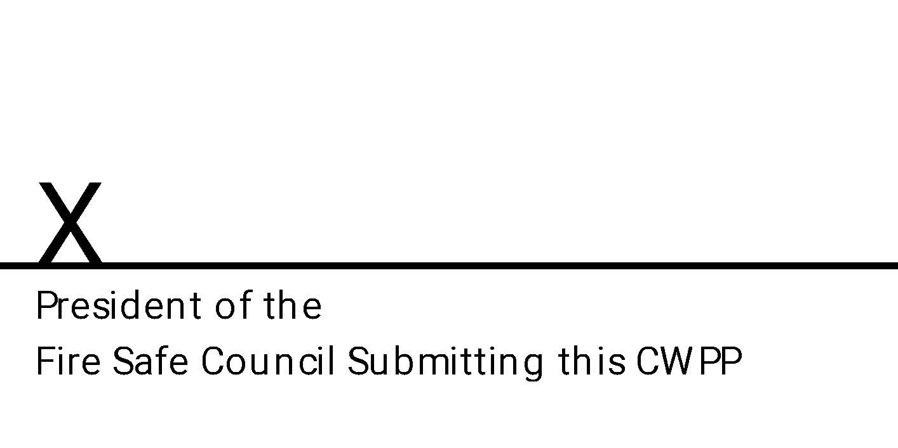
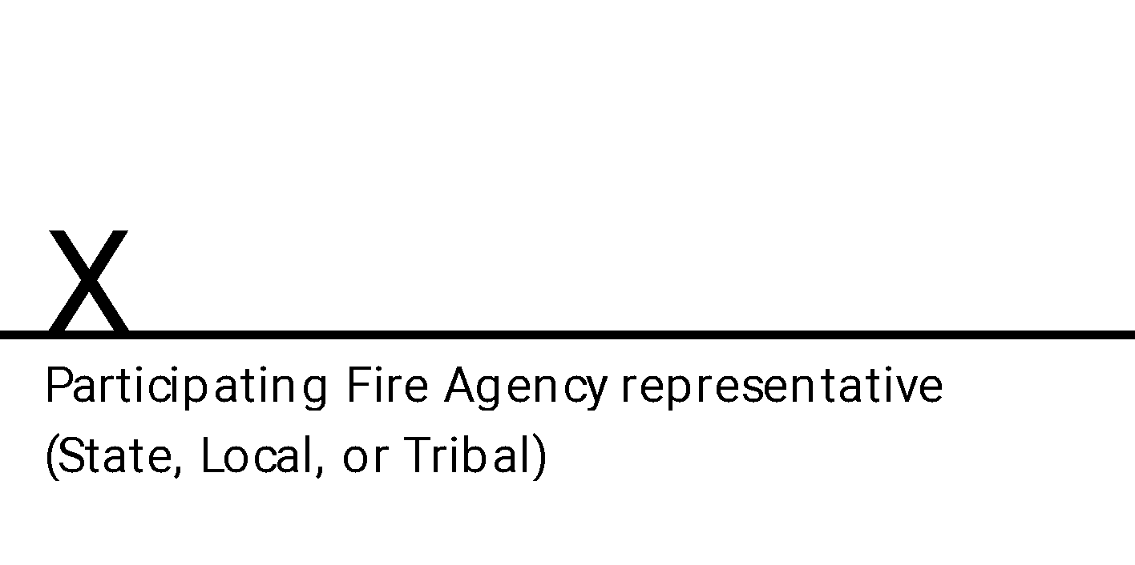

San Diego County Community Wildfire Prevention Plans Review Committee:

This CWPP was reviewed and recommended for approval by the San Diego Community Wildfire Protection Plan Review Committee as demonstrated by the signature below.
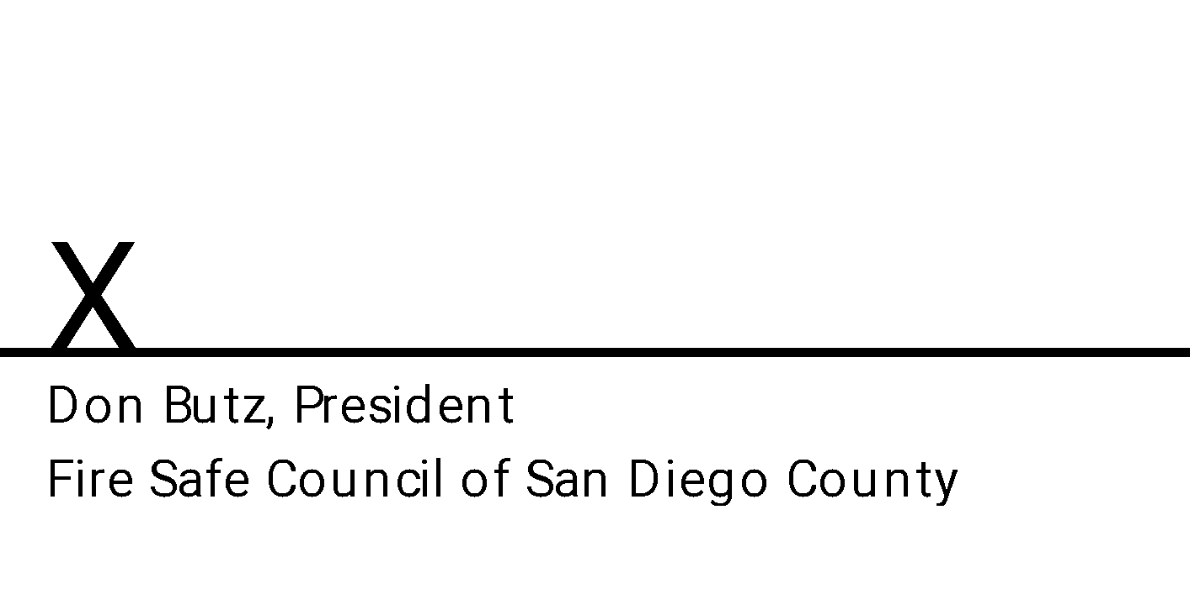

The CAL FIRE Unit Chief has final signing authority on CWPPs in San Diego County. The signature below attests that the standards listed in the section above and the content of this Community Wildfire Protection Plan are proposed to be met and mutually accepted.

10

Appendices

This section includes important additional information that complements other portions of the plan.

APPENDIX A.
MEETING TRACKING DOCUMENTS
This CWPP was developed for the community of Community Name, through a series of community meetings. The Fire Safe Council Name members who contributed to the document include the following:

Community Representatives
- Name here
- Name here
- Name here

Agency Representatives
- Name here
- Name here
- Name here

Meetings Dates
- Date here
- Date here
- Date here

APPENDIX B.
MAPS

Figure 1 Area Communities Map

Figure 2 Fire Hazard Severity Map

Figure 3 Fire History 1910-2010

Figure 4 Evacuation Map

