Community Fire Safe Council Application
Background:
Neighbors worked together with our local fire department and CAL FIRE to form the XXX fire safe council in December 2025 following a small brush fire in our community. We hope to work with our fire department partners to establish wildfire resilience priorities, support neighbors with preparing defensible space and hardening their homes and educate community members on what they can do to be better prepared for wildfire. We hope to support recovery efforts in our community post fire and hope to work on projects to lessen the risk of future wildfires in our community.
Mission Statement:
The Fire Safe Council is a grassroots, community-led organization that mobilizes residents to protect their homes, our community, and environment from catastrophic wildfire through education, assistance, and mitigation.
First Year Goals:
During our integral year of the Fire Safe Council, we plan to collaborate with our local fire department, CAL FIRE, and other stakeholders to accomplish the following:
- Create defensible space through community clean up events, chipping days, and assistance to at risk community members.
- Harden homes and structures through micro grants to residents and community education.
- Increase understanding of wildfire resilience principles through educational home assessments and community workshops.

Fire Safe Council Board Members
Jane Doe, President  jane@firesafecouncil.org  619-123-4567  Address | John Doe, Vice President  john@firesafecouncil.org  619-123-4567  Address | Secretary  secretary@firesafecouncil.org  888-888-8888  Address
Treasurer  treasurer@firesafecouncil.org  888-888-8888  Address | Member at Large  member@firesafecouncil.org  888-888-8888  Address | Member at Large  member@firesafecouncil.org  888-888-8888  Address

Boundary Map
XXX Fire Safe Council covers the same area as our community planning boundary. This map has been vetted and approved by our local fire department and CAL FIRE.
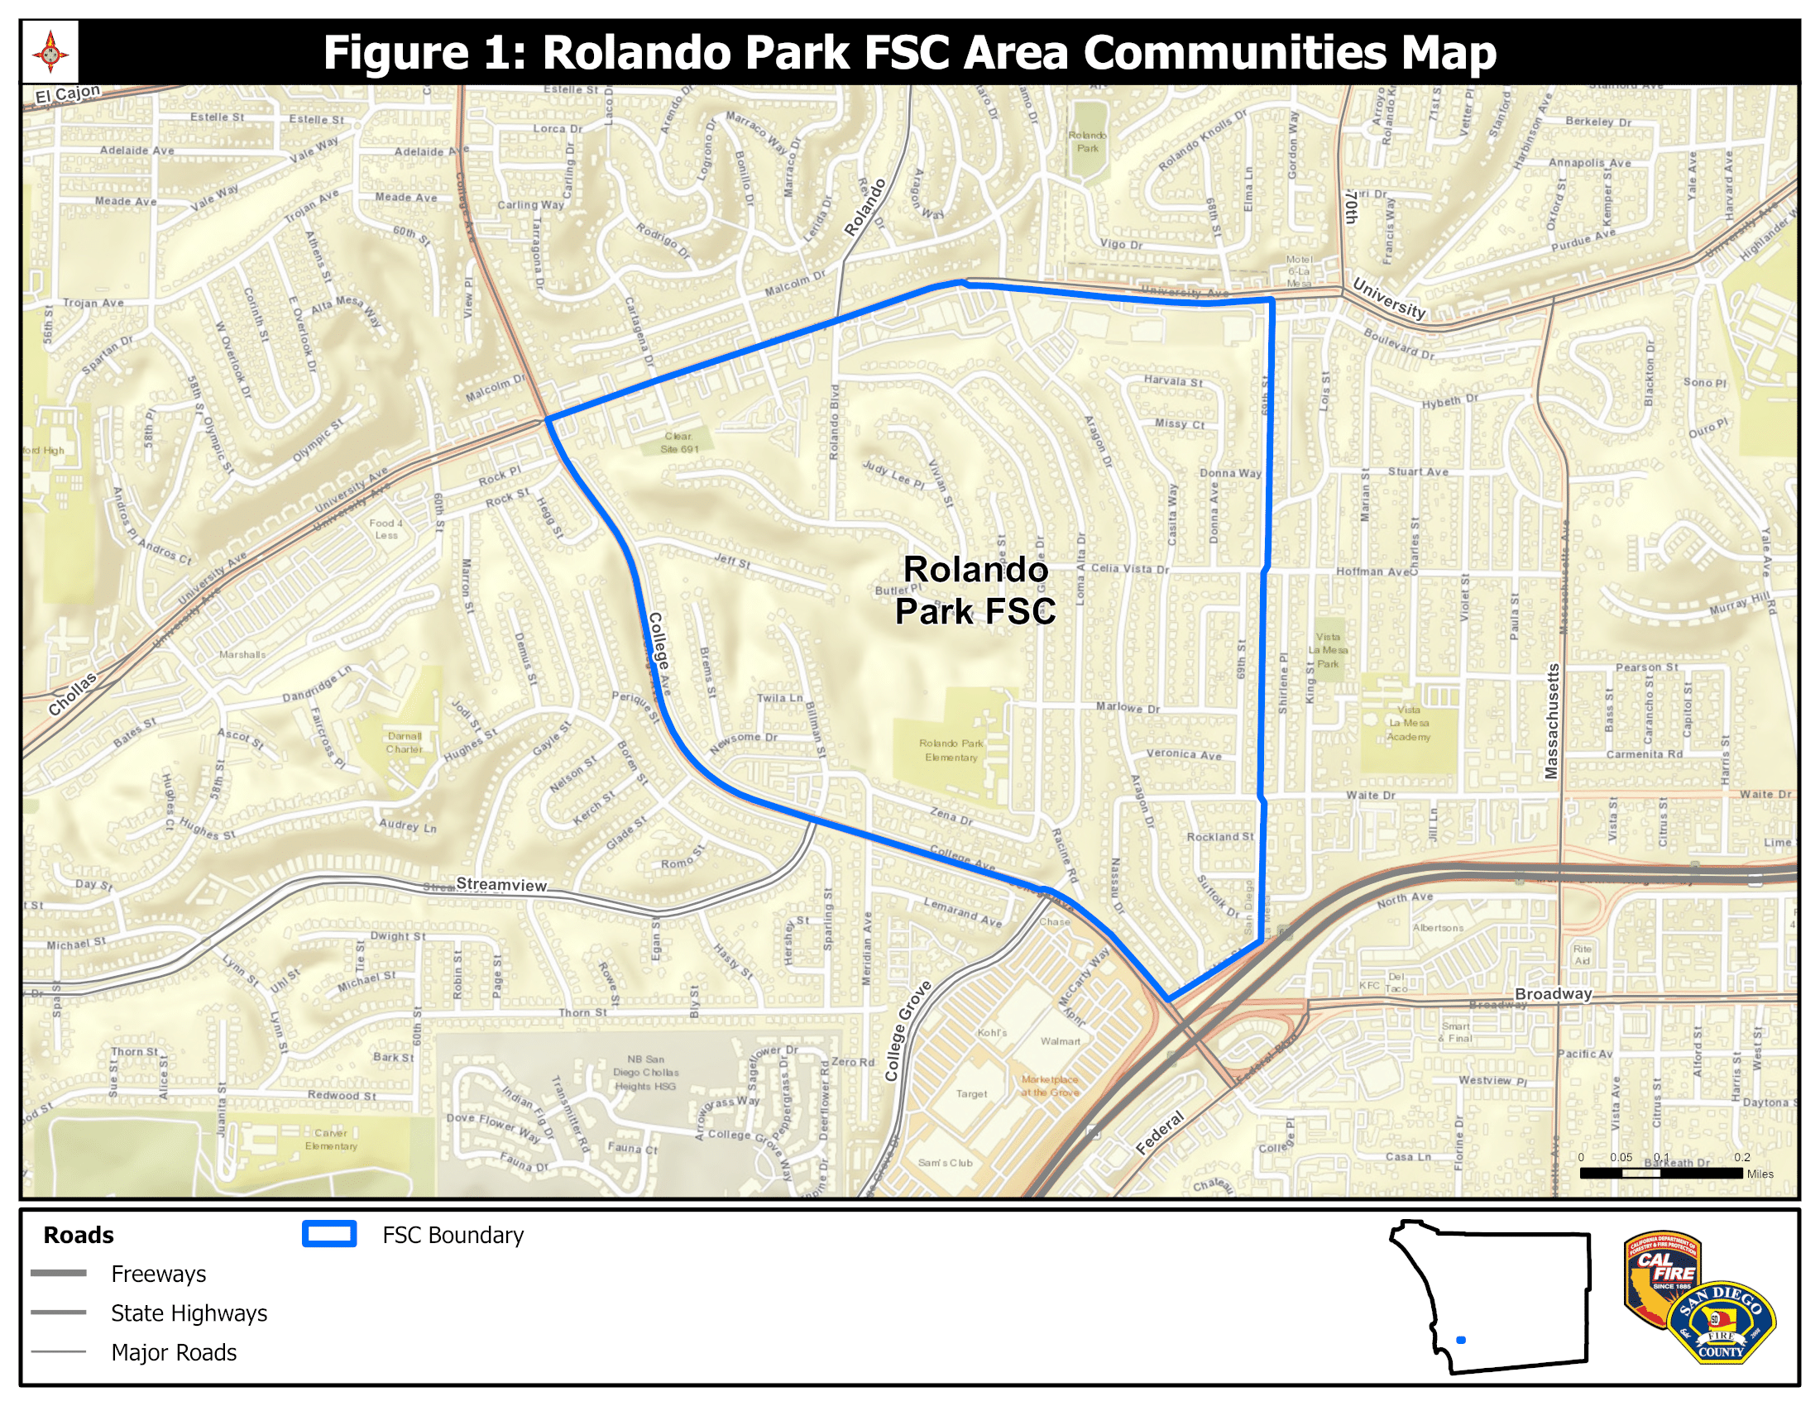
{Insert Map here}

Draft Logo
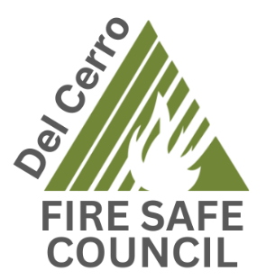
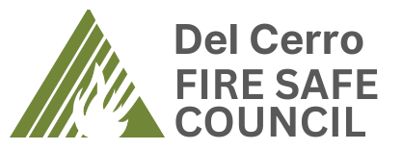
We have received the San Diego County logo guidelines and believe our logo meets the requirements. We are submitting the following logo(s) for review to the FSCSDC Executive Board.

